

Recommended Reads For Year 3
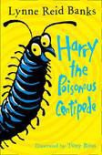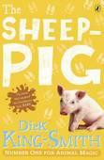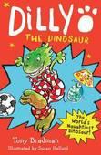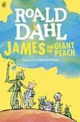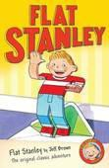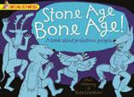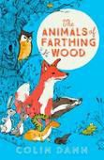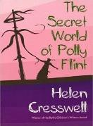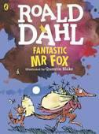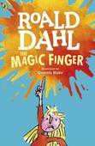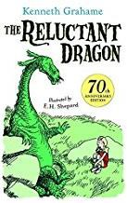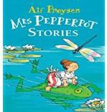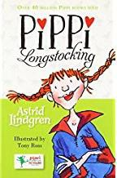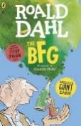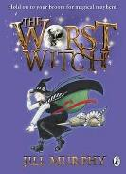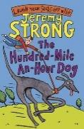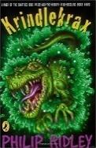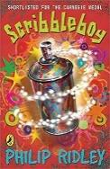

Harry And The Poisonous Centipede

by Lynne Reid Banks
Harry is a centipede who likes to eat things which wriggle and crackle. At the start of the story he is shy but becomes braver. Will his bravery get the better of him & lead him in to trouble?

Dilly The Dinosaur
by Tony Bradman
Dilly is the world’s naughtiest dinosaur, who, amongst other things, refuses to wash; screams the loudest screams and paints the house in an unusual way!

Flat Stanley
by Jeff Brown
When a pinboard falls on top of Stanley, he is left completely flattened. Sent to America in an envelope, will he be able to unflatten himself?

The Secret World of Polly Flint
by Helen Cresswell
The imaginative story of Polly Flint who can see things other children cannot, including a village and its inhabitants which disappeared a long time go.

Fantastic Mr Fox
by Roald Dahl
The timeless story of Mr Fox and how he outfoxes the farmers, Boggis, Bunce and Bean.

The Magic Finger
by Roald Dahl
When Lucy gets upset, she points her magic finger at the person who has upset her. Real magic turns her teacher into a cat & Lucy swears to never use magic again.

The Reluctant Dragon
by Kenneth Grahame
A boy finds a dragon in a cave & he believes it to be harmless & friendly, but how can he convince the frightened villagers and St George, the famous dragon killer?

Mrs Pepperpot Stories
by Alf Proysen
Mrs Pepperpot has a secret- she can shrink to the size of a pepper pot- and when she does, she can talk to animals!

Pippi Longstocking
by Astrid Lindgren
Fearless Pippi’s scared of nothing. She’ll wrestle a circus strongman, dance a polka with burglars and tug on a bull’s tail!

Scribble Boy
by Philip Ridley
Bailey arrives in a new neighbourhood with his extraordinary family. He has no friends but receives a mysterious invitation to join the Scribbleboy Fan Club. His vital mission is to spread the word about Scribbleboy & his amazing scribbles which years ago transformed the gloomy grey concrete of the neighbourhood.

The Sheep-Pig

by Dick King Smith
When Babe, the little orphaned piglet, is won at a fair by Farmer Hogget, he is adopted by Fly, the kind-hearted sheep-dog. Babe is determined to learn everything he can from Fly. He knows he can't be a sheep-dog. But maybe, just maybe, he might be a sheep-pig.

James & The Giant Peach
by Roald Dahl
James Henry Trotter lives with two ghastly hags;. Aunt Sponge & Aunt Spiker. At the end of the garden a peach starts to grow & grow & grow.
Inside that peach are seven very unusual insects - all waiting to take James on a magical adventure.

Stone Age Bone Age
by Mick Manning
Travel back in time for an amazing stone age adventure! Learn to shape flints, carve bones and tickle trout; join in a mammoth hunt and wild dances in flickering torchlight.

The Animals of Farthing Wood
by Colin Dann
Farthing Wood is being bulldozed, & there's a drought. Fox, Badger, Toad, Tawny Owl, Mole & the other animals must band together & set off to a far-away nature reserve. Their journey is full of
adventure & fraught with disasters, & the animals must work together to survive.

The BFG
by Roald Dahl
Telling the story of a young girl called Sophie who stays up way past the witching hour and meets a giant who is far friendlier than the others - who like to eat 'human beans' for dinner!

The Worst Witch
by Jill Murphy
This is the story of how Mildred Hubble became a trainee at Miss Cackle's Academy for Witches, despite being one of the most clumsy children around - constantly getting her spells wrong & crashing her broomstick... Things get even worse
when she turns Ethel, the teacher's pet, into her worst enemy

The 100-mile-an-hour-dog
by Jeremy Strong
It's the Easter holidays & Trevor's mum bribes him to walk Streaker the dog every day. £30 is a big bribe but Streaker can out-accelerate a torpedo, so this is not a doddle of a job. Trevor finally agrees to
the deal, little realising that this won't be the only problem of the holidays...

Krindlekrax
by Philip Ridley.
Ruskin Splinter is small & thin, with knock-knees, thick glasses & a squeaky voice, & the idea of him taming a dragon makes the whole class laugh. But when the mysterious beast, Krindlekrax, threatens Lizard Street & everyone who lives there, it is
Ruskin who saves the day & proves he is the stuff that heroes are made of after all.

.

Recommended Reads For Year 3

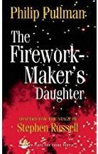The Firework Maker’s Daughter
by Phillip Pullman
What Lila wants to be more than anything else in the world is ...a Firework-Maker! But firework-making is not just about being able to make Crackle-Dragons & Golden Sneezes. There is also one special secret: every Firework-Maker must make a perilous journey to face the terrifying Fire-Fiend!
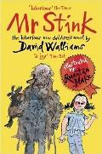
Mr Stink
by David Walliams
It all starts when Chloe makes friends with Mr Stink, the local tramp. Yes, he smells a bit. But when it looks like he might be driven out of town, Chloe decides to hide him in the garden shed. Now Chloe's got to make sure no one finds out her secret. And speaking of secrets, there just might be more to Mr Stink than meets the eye… or the nose

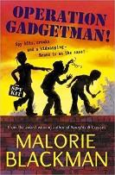Operation Gadgetman
by Malorie Blackman
When Gadgetman accidentally invents a device that could be used to steal millions of pounds, the wrong people find out & Gadgetman is kidnapped!
Beans is determined to track down the kidnappers & rescue her dad. But can she find Gadgetman before he is forced to hand over the details of his invention...?

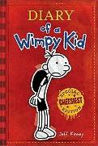Diary of a Wimpy Kid
by Jeff Kinney When Greg finds himself thrust into a new school where undersize weaklings like him share the corridors with other kids who are taller, meaner & already shaving, he decides to piggyback on the popularity of his friend Rowley and finally become cool.

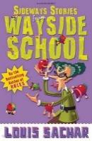Sideways Stories From Wayside School
by Louis Sachar
There has been a terrible mistake. Wayside School was supposed to have been built with 30 classrooms all next to each other in a row. Instead it was built with the thirty classrooms all on top of each other! That’s may be why all kinds of strange stuff happens at Wayside School.
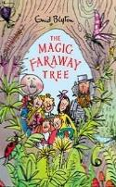
The Magic Faraway Tree
by Enid Blyton
Book 2 in the series. When Joe, Beth & Frannie climb up to the top of the Faraway Tree, they meet Silky, Moon-Face & the Saucepan Man. Their new friends show them an exciting secret - how to visit lots of strange & magical lands, where they have many thrilling adventures.

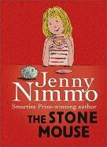The Stone Mouse
by Jenny Nimmo When Elly & her family come to look after her aunt's house, she sees at once that Stone Mouse is special; but her brother Ted says he's just a dirty old pebble. But then Ted is angry with everyone & everything and, as Stone Mouse soon discovers, that means trouble...

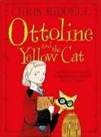Ottoline And The Yellow Cat
by Chris Riddell
Introducing Miss Ottoline Brown, an exceptionally inquisitive Mistress of Disguise, and her partner in crime, Mr. Munroe. No puzzle is ever too tricky for the two of them to solve . . .
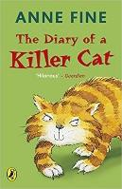
The Diary of a Killer Cat
by Anne Fine
Poor Ellie is horrified when Tuffy drags a dead bird into the house. Who on earth will be the next victim to arrive through the cat-flap? Can soft-hearted Ellie manage to get her beloved pet to change his wild, wild ways before he ends up in even deeper trouble?

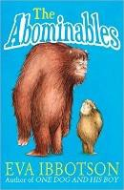The Abominables
by Eva Ibbotson
In a secret valley Agatha Farley is introduced to a family of motherless yetis & devotes her life to their upbringing. She teaches them to speak, tells them stories & insists on polite manners. But as the decades pass, tourists come to the mountains, a hotel is built and yeti-hunters arrive.

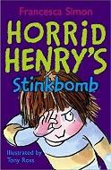 Horrid Henry’s Stink Bomb
by Francesca Simon
Hold your nose! It's stinkbombs at the ready as Henry's Purple Hand Gang goes to war with Moody Margaret's Secret Club. This could get very smelly!

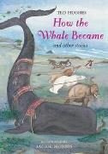How the Whale Became And Other Stories
by Ted Hughes
Long ago when the world was brand new, before animals or birds, the sun rose into the sky & brought the first day. To begin with, all the creatures were pretty much alike - very different from what they are now.

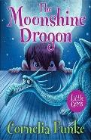The Moonshine Dragon
by Cornelia Funke
When a tiny silver dragon is chased out of Patrick's storybook by an equally tiny knight, all sorts of mayhem breaks loose! Soon moonshine magic has shrunk Patrick too, & he is forced to hole up inside his toy castle as the knight attacks the 'fire worm'. Can Patrick defeat the knight and make it to morning?

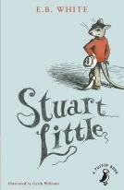Stuart Little
by E.B/ White
Stuart Little is no ordinary mouse. Born to a family of humans he lives in New York City with his parents, his older brother George & Snowball the cat. When his best friend, disappears from her nest, Stuart is determined to track her down.

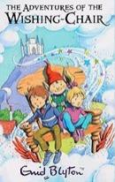The Adventures of the Wishing Chair

by Enid Blyton
The magical chair can not only grant wishes, but it also sprouts wings and transports the children to a giant's castle, the Land of Dreams and a disappearing island.

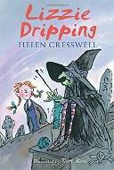Lizzie Dripping
by Helen Cresswell Everyone in the village where Lizzie lives thinks that she's a dreamer - so it's no wonder that they don't believe her when she says she's seen a witch. But Lizzie doesn't care because she knows it's true and having a witch for a friend makes life much more exciting.

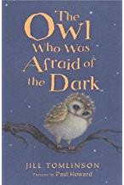The Owl Who was Afraid of the Dark

by Jill Tomlinson
A young Owl, called Plop, is afraid of the dark- something which makes life of an owl quite difficult.

