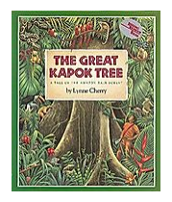
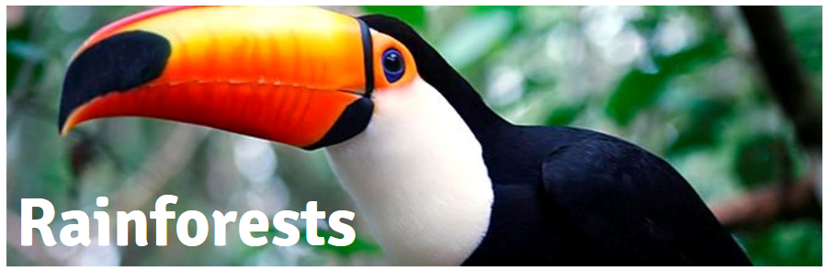
The Great Kapok Tree
Lynne Cherry
This is a colourful and engaging picture book that captures the spirit of the rainforest through its beautifully detailed illustrations. It has a simple storyline that is accessible to less confident readers but a strong message about deforestation and enough depth to captivate older readers too.

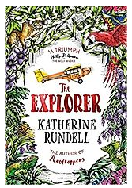
The Explorer
Katherine Rundell
Winner of the Costa Children's Book Award 2017, 'The Explorer' is set in the Amazon and follows the story of Fred, whose plane accidentally crashes into the rainforest canopy.

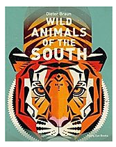
Wild Animals of the South
Dieter Braun
This is a stunning compendium of different animals living the in the Southern Hemisphere, including (but not exclusive to) a wonderful selection of rainforest creatures, including sloths, jaguars, macaws and gorillas. Each double-page spread covers a different animal and includes a beautiful illustration along with a short paragraph of informative text. This is a highly appealing book that is perfect for finding out about rainforest animals and comparing them with other creatures from different global habitats.

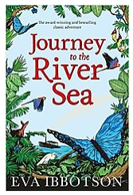
Journey to the River Sea
Eva Ibbotson
Winner of the Smarties Book Prize Gold Award, this is a very popular choice for KS2. It tells the story of a small girl called Maia, who journeys down the Amazon River with her strict governess, making friends and enemies along the way. It is rich in descriptive language in both its depiction of the Brazilian jungle and in its descriptions of complex and cruel characters that will stay with you long after you close the book.

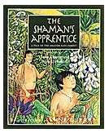
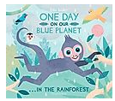
The Shaman's Apprentice
Lynne Cherry & Mark Plotkin
Set deep in the Amazon rainforest, this is a thought-provoking story about preserving cultural values in a changing world. The beautiful illustrations in this picture-book, including its excellent picture glossary, show the immense diversity of rainforest plants. Another popular choice for KS2.

One Day on our Blue Planet: In the Rainforest
Ella Bailey
Part of the popular 'One Day on our Blue Planet' series, this beautifully illustrated picture book charts the wildlife in the rainforest across the course of a whole day. Informative and visually appealing with accessible text, this is a winner for the classroom.

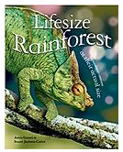
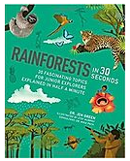
Lifesize: Rainforest
Anita Ganeri & Stuart Jackson-Carter
The concept of this book is to show different rainforest creatures at their actual size (or the parts of them that fit on the page at least!). From tiny tree frogs to birds of paradise to anacondas, this photographic information text is a great stimulus for comparing rainforest animals.

Rainforests in 30 Seconds
Jen Green & Stephanie Murphy
The ‘In 30 Seconds’ series of non-fiction texts aims to provide information on various different aspects of a topic in small chunks of text taking approximately 30 seconds to read (we averaged at 27.5!). This text is pitched for KS2 and is accompanied by a range of pictures, infographics and glossaries, making it accessible and appealing to children. Topics include biodiversity, conservation, layers of the rainforests and explorers.

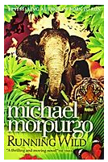
Running Wild
Michael Morpurgo
This novel, by the popular children's author Michael Morpurgo, is set in the Indonesian Rainforest. It tells the story of Will, who is left fighting for survival in the rainforest with an enchanting elephant called Oona.

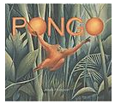
Pongo
Jesse Hodgson
Where Pongo the Orangutan lives in the depths of the rainforest, it can feel wet and gloomy as the sunlight hardly ever finds its way through to the forest floor. Pongo decides to journey up the layers of the rainforest in search of the light and warmth and along the way finds that the rainforest harbours lots of shapes and colours that resemble the sun (some more humorous than others!). This is a stunning picture book that enchantingly depicts the shapes and colours of the rainforest.

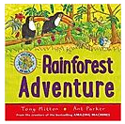
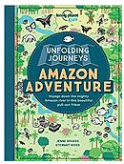
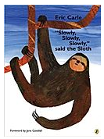
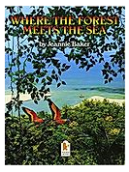
Rainforest Adventure
Tony Mitton & Ant Parker
An easy-to-read picture book for younger classes or less confident readers. This text introduces the wild and wacky creatures of the rainforest in a fun and accessible way.

Amazon Adventure: Unfolding Journeys
Stewart Ross & Jenni Sparks
This visually appealing book from Lonely Planet Kids unfolds as you read it into a 16-panel long wall frieze. The pages take the reader on an informative journey down the Amazon river, snaking through the deepest rainforest and the surrounding geographical regions and cities. The journey map is packed with illustrations, icons, labels and facts. On the reverse of the frieze, there are paragraphs of further information about different points of interest from the journey, including rainforest animals and tribal villages.

Slowly, Slowly, Slowly, said the Sloth
Eric Carle
Illustrated in Eric Carle's iconic painted collage style, this book celebrates the sloth. When the other animals question the Sloth's 'lazy' ways, the Sloth poetically explains that sometimes slow is best.

Where the Forest Meets the Sea
Jeannie Baker
If you are looking for a book to stimulate discussion and debate about the effects human beings can have on the natural world, this if the one for you. The illustrations are so incredibly detailed (there is also a big book edition available on Amazon that is perfect for detail-spotting) that you might be forgiven for thinking that some of them are photographs. The book has won multiple awards and is sparking deep consideration of the past, present and future of the rainforest.

