


Reading at home

Tips for reading with children of any age:-
- Set aside some time
Find somewhere quiet without any distractions - turn off the TV/radio/computer.
- Ask your child to choose a book
Sharing books they have chosen shows you care what they think and that their opinion matters. This means they are more likely to engage with the book. It doesn't matter if it's fiction, poetry, comic books or non-fiction. All reading is good – don’t rule out non-fiction, comics, graphic novels, magazines or leaflets. Reading is reading and it’s all worthwhile.
- Sit close together
Encourage your child to hold the book themselves and/or turn the pages. Snuggle up together somewhere warm and cosy, whether it’s in bed, on a beanbag or on the sofa. And make sure your child has somewhere comfy to read on their own too.
- Point to the pictures
If there are illustrations, relate them to something your child knows. Ask them to describe the characters or situation or what will happen next. Encourage them to tell you the story by looking at the pictures.
- Encourage your child to talk about the book
Talking about the characters and their dilemmas helps children understand relationships and is an excellent way for you to get to know each other or discuss difficult issues. Give your child plenty of time to respond. Ask them what will happen next, how a character might be feeling or how the book makes them feel. ‘Where did we get to last time?’, ‘Can you remember what’s happened so far?’ and 'What do you think will happen next?'
- And lastly, above all - make it fun!
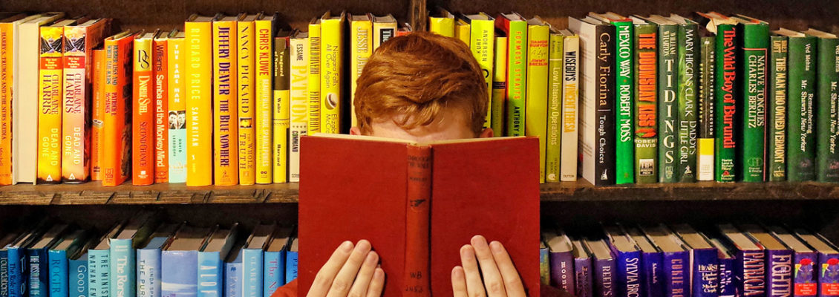
It doesn't matter how you read with a child, as long as you both enjoy the time together. Don't be afraid to use funny voices - children love this! Read favourites again and again – encourage your child to re-read the books and poems they love. Re-reading helps to build fluency and confidence.

