The Herefordshire Primary Computing Progression: Recommended iPad Apps

If you’ve looked in the iPad App Store you’ll know that there’s a bewildering array of apps available. This list attempts to identify a few tried and tested ones that work in primary schools. The list is also about identifying core, open ended, creative, productivity apps that support the computing curriculum (organised to match headings in the Herefordshire Primary Computing Progression). The IT strand comes first because that’s where the best gains are with iPads.

A shaded background in the description column indicates what we consider to be the core apps for this particular area. If there is a white background these apps are nice to have.

In addition to the apps listed here there are, of course, thousands that are great for supporting discrete aspects of primary curriculum. There are other great places online to begin looking for such apps is like graphite.org, particularly if you’d like to see a quality review of an app. But don’t get carried away – you’ll fill up your iPad.

Don’t forget that Apple’s volume purchasing agreement means that once you buy 20 copies of most apps the price drops by half. For more information on anything below, click on the app icon and you’ll be taken to the iStore where you can read the official blurb and, if you’re on an iPad / iPhone, download the app.

Information Technology: Text & Design
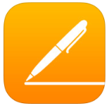 | Pages (free) EYFS KS1 KS2  This is the app version of Apple’s main word processor with parallels to Microsoft Word. Most things are possible as well as a vast array of sharing options. Free for all iPads registered after 09/2013. £6.99 for older iPads.
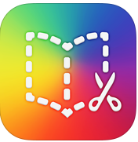 | Book Creator (£4.99 [free version not good enough]) EYFS KS1 KS2  A fantastic app for primary use. Children can easily create and share (via iBooks) a simple or much more complex book which immediately looks professional. Multimedia elements can be included easily. Comic style books can also be created. Sharing options are great (including as a video) and as an added bonus you can combine books.
 | Keynote (free) EYFS KS1 KS2  Keynote is the Apple equivalent of Microsoft’s PowerPoint and is part of the Apple iWork suite. Well worth having. Keynote also has some really impressive tools for 2D, computer generated animation.
 | Popplet (£4.99) EYFS KS1 KS2  Not a priority, especially given the price but a good planning tool. This app produces mind maps. The paid for version allows for collaborative editing of a single “popplet” on multiple iPads, also allows more than one file to be on the go. Popplet Lite is available for free but very limited.
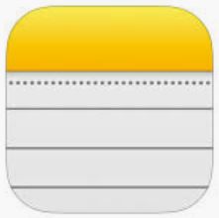 | Notes (free) EYFS KS1 KS2  If you just want to focus on basic text (but now with many advanced features in this app) don’t underestimate the power of the Notes app that will be on your iPads anyway.

Information Technology: Image
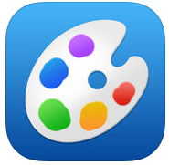 | Brushes Redux (free) EYFS KS1 KS2  A great universal painting app used in many schools. Has an impressive array of features for a free app and has been designed exclusively for iOS. Painting is smooth and responsive — even with huge brush sizes. Brushes also records every step in your painting.
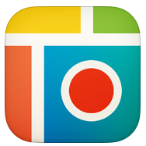 | PicCollage Grid & Photo Editor (free) EYFS KS1 KS2  A lovely app that will allow you to combine pictures from the camera roll into beautiful displays. It’s possible to add text and annotations as well as “stickers” so it’s really a simple DTP app. A great way for children to record findings etc. Also works with video. If you can afford it (£1.99) PicCollage EDU is designed especially for safe use in schools

Information Technology: Image (animation)
 | I can animate / Animate it (£2.99 or “lite” for free) EYFS KS1 KS2  The cross platform software of the same name is a tried and tested stop frame (3D) animation tool. This is a cut down version of it for the iPad. It works well, though the challenge is to keep the iPad still. (Animate it is exactly the same app in different clothing) There is a “lite” version for free with more limited functionality.
 | Puppet Pals HD Director’s Pass (£3.99) EYFS KS1 KS2  A great tool for creating 2D animations. Children place characters or themselves into situations using backgrounds in the app or captured using the camera. They then act out their scene with speech all of which is recorded. There is a free version of this app but it’s far too limiting and should be avoided. Please don’t confuse this with Puppet Pals 2.
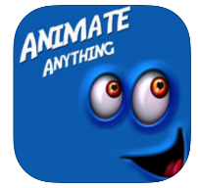 | Animate Everything (free) EYFS KS1 KS2  Animate any photograph. Record speech to make your character talk. Finished products can be saved to the camera roll and then imported into other video projects etc. Great for brining historical or story characters to life. The best of a very large crop of similar apps! If you want something simpler then:
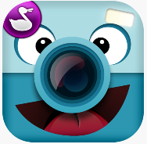 | ChatterPix Kids (free) EYFS KS1 KS2  Does the same job as Animate Everything, not quite so beautifully but more easily. Ideal for EY and KS1
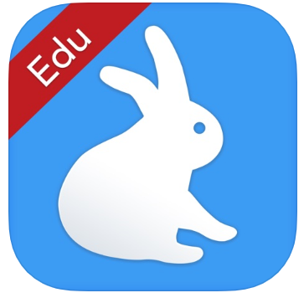 | Shadow Puppet Edu (free) EYFS KS1 KS2  An excellent app that has nothing to do with shadows, puppets or rabbits! It allows the user to string together a collection of images and to add a narration and some animation to tell a story, write up a science experiment …

Information Technology: Image (video)
 | iMovie (free) EYFS KS1 KS2  A cut down app version of the classic Apple video editor. Packed with features and the obvious choice as a movie editor. The iPad is an ideal video editor for quick and easy movies. Footage captured by the camera (and stills) goes straight into iMovie. Free for all iPads registered after 09/2013. £2.99 for older iPads.
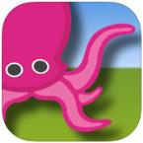 | Green Screen (£2.99) EYFS KS1 KS2  iMovie now has its own support for green screen but this is a really easy to use green screen app. Would I buy it now that iMovie does it? Probably not. Green screening involves filming against a green background which is then removed and replaced with something else (moving or still) placing the subject of your film anywhere.
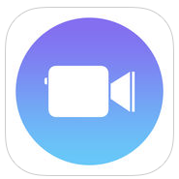 | Clips (free) EYFS KS1 KS2  A lovely app from Apple. Aimed at the home market as a means of capturing and easily and amusingly packaging a short piece of video. It has a host of features that make it excellent (and fun) for education, especially when used by children to explain concepts ect. Needs iOS 10.3 or later so no good for older iPads

Information Technology: Sound
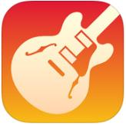 | Garage Band (free) EYFS KS1 KS2  A stunning app. The number one app for music composition. Children can easily create music with little understanding, at the same time it can be used to teach music at a sophisticated level. It’s also good for recording narrated audio etc..

Digital Literacy: Data handling – spreadsheets & data
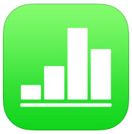 | Numbers (free) EYFS KS1 KS2  Numbers is a spreadsheet app - Apple’s equivalent to Microsoft’s Excel and the app is specifically designed for a tablet, of course. An essential app for KS2 especially now that it’s free. Free for all iPads registered after 09/2013. £6.99 for older iPads.
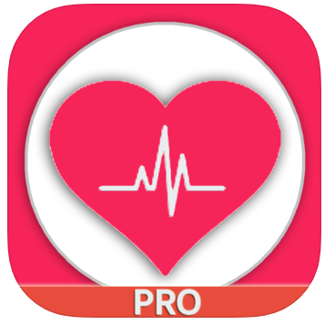 | My Heart Rate Monitor ... (free) by Atthaporn Chanprakon EYFS KS1 KS2  Not an essential app by any means but this will allow you to take pulse rates (so simple data logging). It needs a certain amount of light to be shining through your finger which you put on the camera. Lots of apps claim to do this but they don’t all seem to work. You don’t need the pro version.
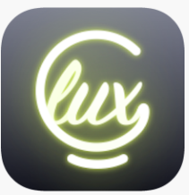 | Lux Meter from Lumi (free) EYFS KS1 KS2  Not an essential app by any means but this will allow you to take readings of light levels (so data logging). There are plenty of alternatives which are probably just as good.
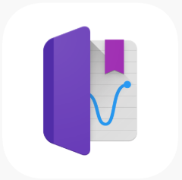 | Science Journal – from Google (free) EYFS KS1 KS2  An app that allows data collection (data logging) via a variety of sensors (unfortunately not temperature as there is no thermometer in the iPad)

Computer Science: Programming
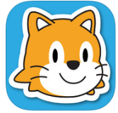 | Scratch Jr (free) EYFS KS1 KS2  www.scratchjr.org Aimed at KS1 and a lovely programming environment which includes a subset of commands from Scratch (its older and bigger brother) that are just right for KS1 and even lower KS2. The web link given here is to a website for education professionals where some learning and teaching resources are already appearing.
Scratch 3 (free) EYFS KS1 KS2
As of 2019 Scratch (version 3) now works on iPads. There is no app just use Safari to go to https://scratch.mit.edu. You will need to create a Scratch Teacher account and create logins for your children. There’s no point in messing about with any other solution.
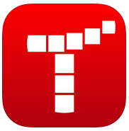 | Tynker (free) EYFS KS1 KS2  Based on Scratch and supports a range of programmable robots and drones. There is a very comprehensive scheme of work etc which comes at great cost but the free app itself, without that is still very useful. There is a range of tutorial activities built in. Also really good at connecting to external devices like drones.
 | Bee-Bot (free) EYFS KS1 KS2  A free app from TTS. There are 12 mazes of increasing complexity around which children write programs to program the bee-bot. Points are given as they do so. A must for all EYF and KS1 children. Ideally children will have had experience of programming a bee-bot in real life before or alongside this. Bee-Bot Pyramid takes this on further into an Ancient Egyptian setting again with 12 mazes.
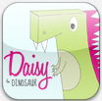 | Daisy the Dinosaur (free) EYFS KS1 KS2  A great little app for EYFS and KS1. Best to use it in challenge mode first where five simple challenges teach children how to use it. After that, free-play mode allows them to set their own challenges. Based on simple Logo programming and great for EYFS / KS1

Workflow / File sharing / Classroom management / Misc.
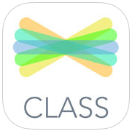 | Seesaw (free) EYFS KS1 KS2  This is a great platform to allow children to compile and share their own learning journal or digital portfolio with the class (and parents if you wish) through a self-contained class blog. It’s totally free (unless you want to pay for some of the more advance features). There is a parent app too. Everyone should use this!
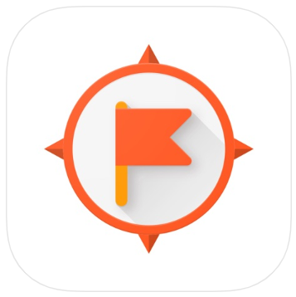 | Google Expeditions (free) EYFS KS1 KS2  A truly amazing resource, that allows you t take your class on a virtual trip to thousands of locations. It’s designed for use with VR headsets but works perfectly well with iPads. There is also scope to make your own expeditions which can be used for a variety of purposes, in a range of formats for numerous audiences. A wonderful totally free tool from Google.
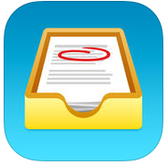 | Showbie (free) EYFS KS1 KS2  A really easy way of dealing with workflow in the classroom. Teacher uploads content, children easily join your “class” open your files edit / annotate them, teacher “marks” them and sends them back. Totally cross platform, children can login at home etc. It’s free to use at a basic level (quite expensive for more functionality but you should probably look to Google Apps for Education when you need more.
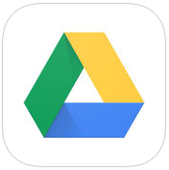 | Google Drive (or other cloud storage app )(free) EYFS KS1 KS2  Cloud storage from Google. An easy way to share files between and from iPads (create a free Google account, login to that account on all iPads and you have a shared drive. Because it’s cross platform and web based you can drop files there / take them off on any computer (anywhere).
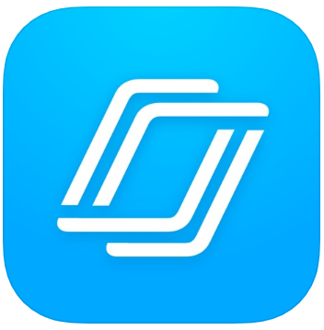 | Nearpod (free) EYFS KS1 KS2  Take a PowerPoint presentation and push it out to the iPads in front of the children. You control movement through the pages but they interact with some pages which you can create to contain questions, text pages, drawing etc which they complete and send back to the teacher. Great for assessment. Other solutions exist (including a promising one from Promethean still being developed)but this is a good place to start for now.
 | iTranslate (free and priced) EYFS KS1 KS2  There are various versions of this, offering different functionality. It’s worth typing “iTranslate” into the app store and considering what you need for your children. Great for EAL etc.
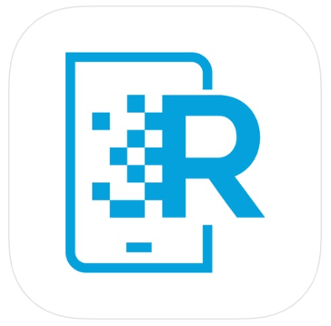 | HP Reveal (was Aurasma) (free) EYFS KS1 KS2  Enter a whole new world of augmented reality! This app allows you to capture an image and link it to a video file (ideally) that you have created and uploaded. When the user captures the image on their iPad or iPhone using the app the image comes to life. Worth a look bu can be problematic.
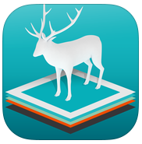 | Zookazam (£0.99) EYFS KS1 KS2  An amazing app. It uses augmented reality to bring a whole range of animals into your own environment. They are presented in fantastic detail and are animated. A great trigger for conversation and learning (there are more spoken details in the app too. Amazing value!

